CHAPTER 5: RESULTS AND DISCUSSIONS

5.1 Evaluation Metrics

RMSE (Root Mean Squared Error) is computed for the active forecasting model (Linear Regression) and displayed on the results page.

5.2 Output Screens
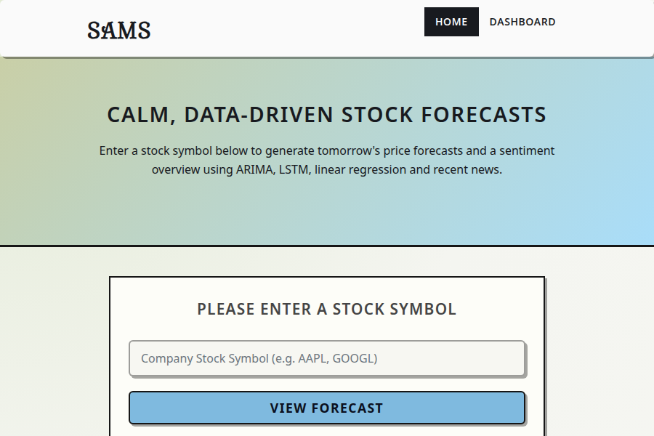
Home / Prediction Studio page

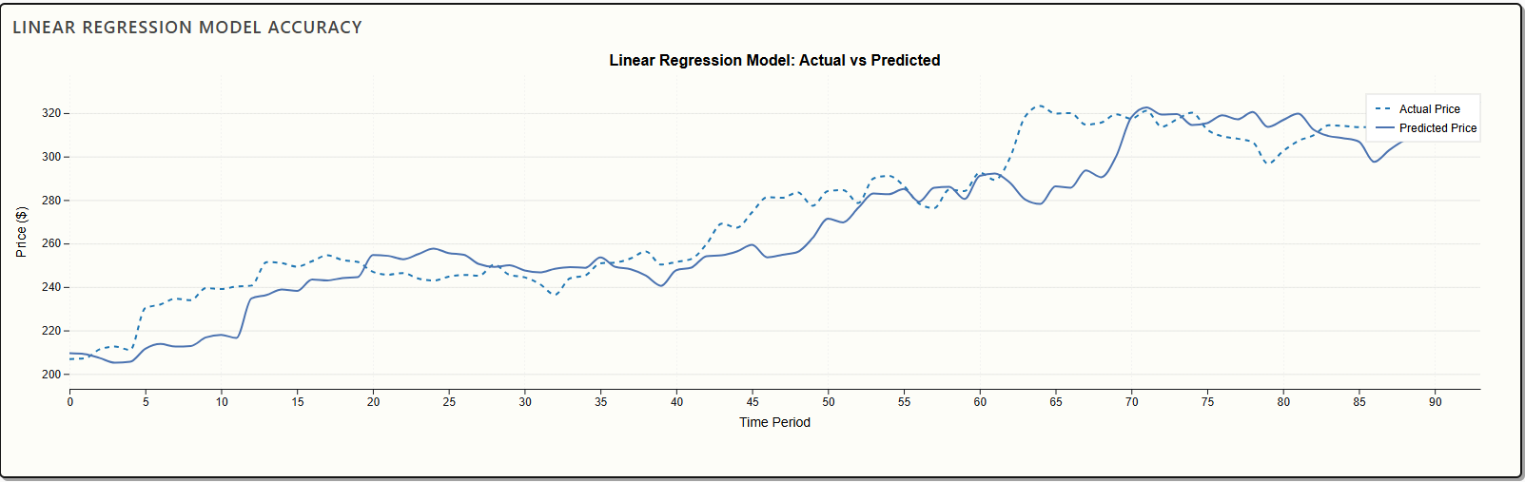
LR model test graph
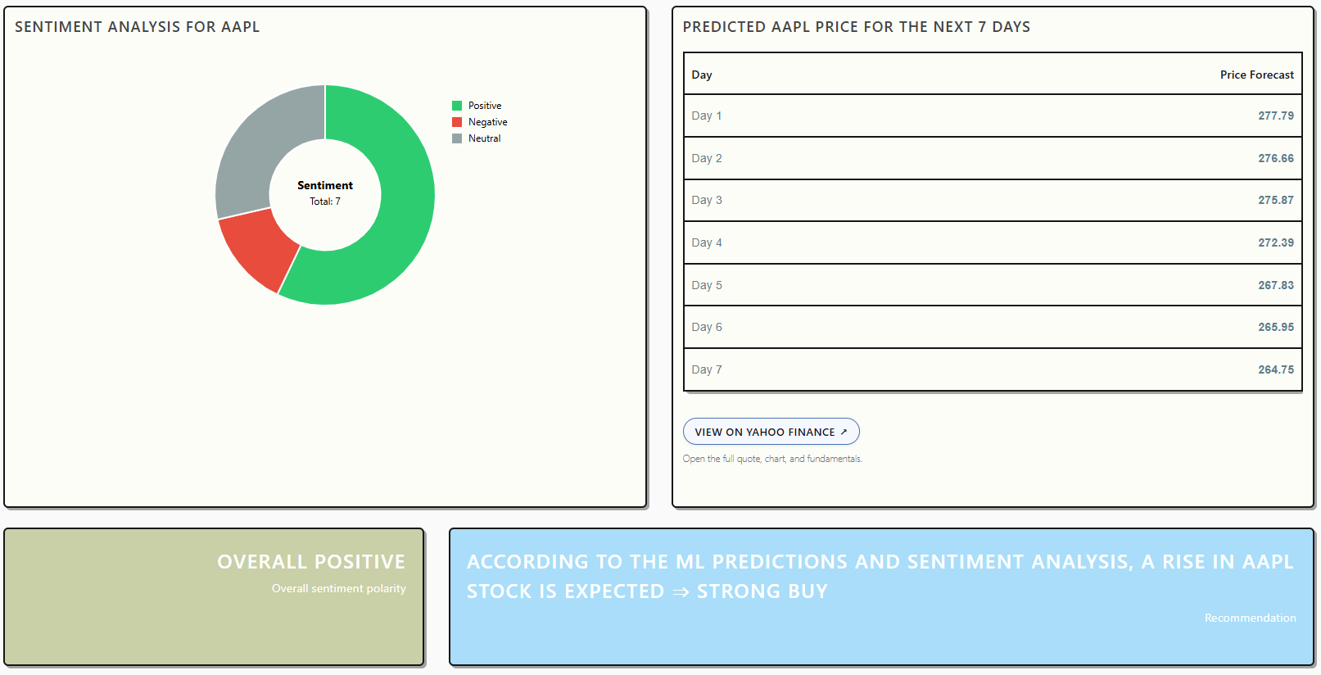
7-day forecast table and Sentiment Chart
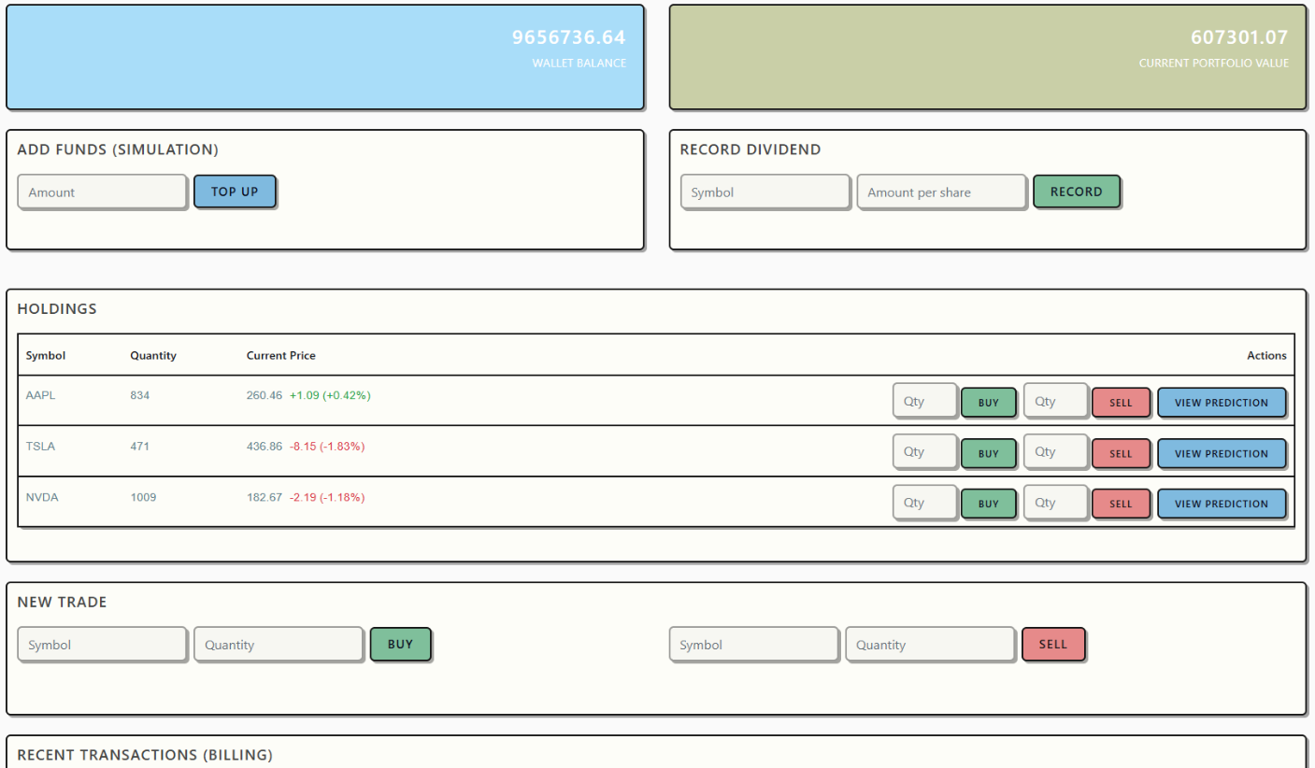
Stocks trading and dividends management

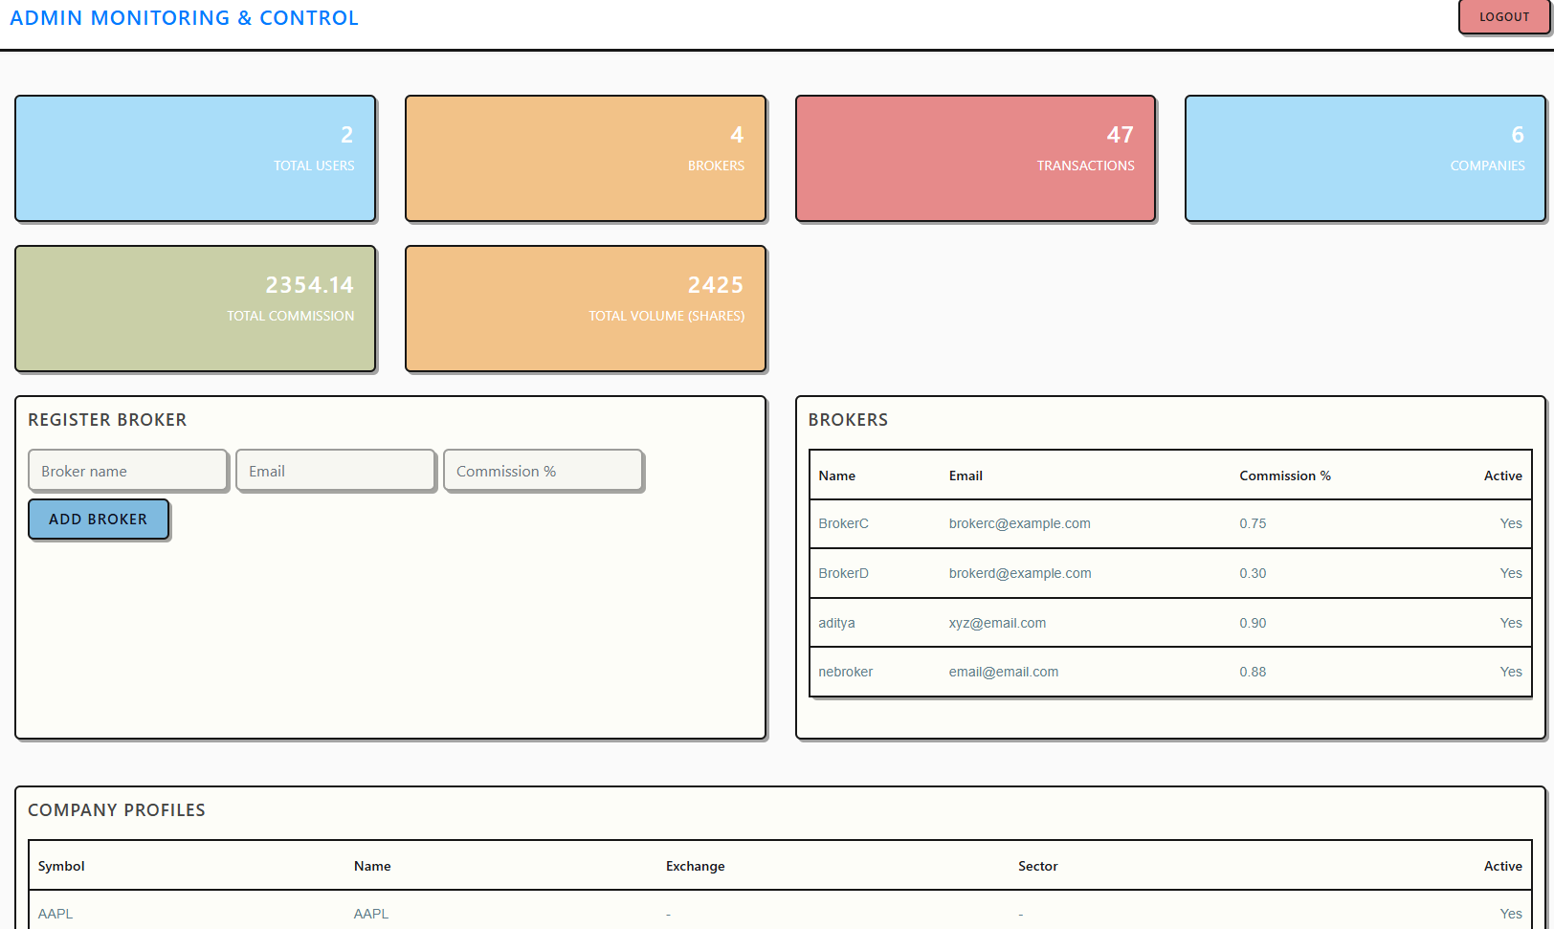
Admin dashboard and Broker management with Company management
5.3 Discussion

- The system provides a unified view combining technical forecasting and sentiment context, addressing the integration gap identified in the literature [1], [5].
- The Linear Regression model delivers fast response times suitable for web applications while maintaining interpretable predictions [2], [3].
- Feature scaling and proper train-test splitting ensure robust model performance as recommended by recent studies [2], [4].
- The 7-day forecast horizon provides actionable short-term predictions that align with practical trading strategies.
- The sentiment engine is designed with multiple fallback sources to remain operational even when primary data sources are unavailable.
- The combination of quantitative forecasting and qualitative sentiment analysis provides a more comprehensive decision-support framework than either approach alone.

